SIMATS ENGINEERING

ASSESSMENT TOOL 3 - Output Prediction

COURSE NAME: Data Structures COURSE CODE: CSA03
Register Number
Name
Assessment Tool Weightage: 35%

COURSE OUTCOME COVERED

CO1: Apply suitable data structures and ADTs for efficient problem solving by analyzing time and space complexity. (BL3, BL4)

Questions: 5 EACH QUESTIONS CARRIES: 5 MARKS Total Marks: 25 Duration: ONE HOUR

S. No. | 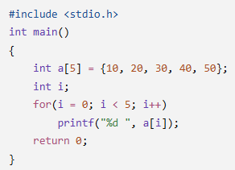  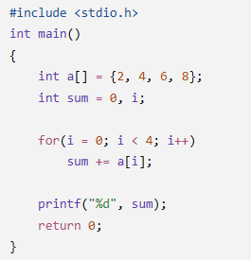  List of Questions
1 | Array Traversal Program
2 | Sum of Array Elements Program

3 | 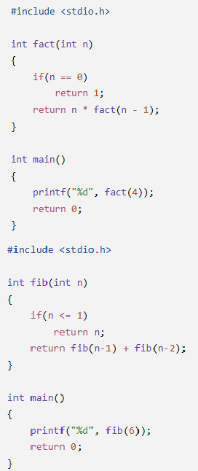  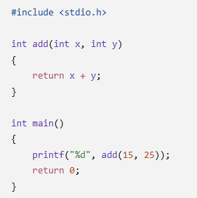  Recursive Factorial Program
4 | Recursive Fibonacci Program
5 | Function as ADT Operation Program

Code of Conduct:

I (Name / Reg No) certify that this submission is my original work and that I have adhered to the guidelines specified for this assessment.
I understand that any violation of academic integrity rules will result in disciplinary action.

Signature of the student:

RUBRICS FOR CALCULATION:

Criteria | Weightage (5 Marks) | Level 4 – Exemplary  (5 Marks) | Level 3 – Proficient  (4 Marks) | Level 2 – Developing  (3 Marks) | Level 1 – Beginning  (1–2 Marks)
Understanding of Program Logic | 1 | Correctly identifies the complete program flow and execution  sequence. | Minor misunderstanding of program flow. | Partial understanding of logic. | Unable to  interpret the program logic.
Trace of  Variables / Function Calls | 1 | Accurately traces all variable values, iterations, and  recursive calls. | Traces most values correctly with minor errors. | Traces some values but misses important steps. | Incorrect or no tracing.
Output Prediction Accuracy | 2 | Output predicted  completely and correctly. | Output mostly correct with minor mistakes. | Output partially correct. | Output  incorrect or missing.
Complexity Interpretation (Time/Space) | 1 | Correctly identifies and justifies complexity where  applicable. | Correct complexity with limited  justification. | Partial understanding of complexity. | Incorrect or no complexity analysis.

